
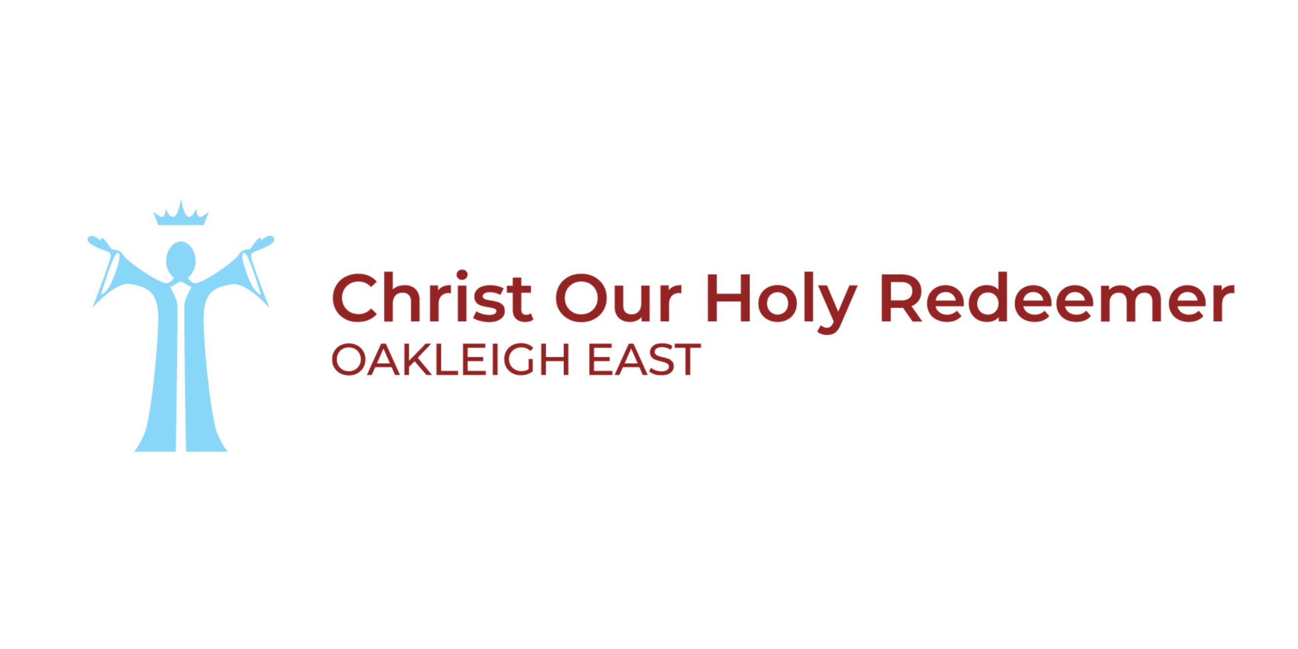

Concessional Fee Program – Procedures

Introduction
These procedures outline the process for applications for concessional school fees in Melbourne Archdiocese Catholic Schools Ltd (MACS) primary schools.

Purpose
The purpose is to set out the procedures for the provision of fee concessions in MACS primary schools.

Procedures
- Eligibility for Concessional School Fees
Families may qualify for concessional school fees if they meet any of the following criteria:
  - General eligibility criteria
- of Aboriginal or Torres Strait Islander heritage
- holding Services Australia Health Care Cards (HCC) and eligible for Camps, Sport and Excursion Fund (CSEF)
- holding a Department of Veterans’ Affairs (DVA) Gold Card
- identified as refugees holding Department of Home Affairs Proof of Identity card (ImmiCard)
- refugees, where the child has attended a school within Australia for less than five years
- experiencing genuine financial hardship (e.g., loss of family home, and/or loss of income through volunteering to fight bushfires, COVID-19 or illness and/or loss of livelihood/income caused by bushfires)
  - Special Medical Circumstances
Any family required to relocate their (Australian resident) child to St Michael’s Catholic Primary School, North Melbourne, due to the child requiring long term medical treatment at The Royal Children’s Hospital, Melbourne will be eligible for concessional student fees. Pro-rata concession is provided for part-year attendance. An annual statutory declaration is required to confirm eligibility.
  - Home schooled students ( HSS): who attend a MACS primary school on a part time basis, who meet any of the criteria detailed in 1.1 or 1.2 are eligible for concessional student fees.
- Ineligibility for Concessional School Fees
Full Fee-Paying Overseas Students (FFPOS) are ineligible for concessional school fees, as government funding is not available for these categories.
- Concessional School Fees for Eligible Students
Concessional fees (including tuition fees and levies) for eligible students are subject to an annual review for reasonableness and ongoing suitability. The fee assessment is conducted by General Manager, School Finance and approved by the Chief Financial Officer of Melbourne Archdiocese Catholic Schools. All MACS primary schools are required to comply with this assessment prior to setting fees.
Refer to the current year’s concessional fees notice for the applicable concessional fee information.

- Application for Concessional School Fees
  - Applications for a concessional school fee must be made on the school approved form and emailed to the school every year prior to the commencement of term 1 of the school year, except for families of Aboriginal or Torres Strait Islander heritage. These families are not required to reapply once their initial application has been approved.
  - Information provided in support of concessional school fee applications must be treated in the strictest confidence, in accordance with the MACS Privacy Policy.
- Approval process for Concessional School Fees Applications

  - The school principal is delegated the authority to approve concessional school fees applications.
  - A principal’s approval or decline of concessional school fees applications should be retained in writing.
Successful Applications:
  - When an application for concessional school fees is approved, an automated payment plan must be established. Where applicable, the payment plan should be set up through CentrePay or via direct credit to the school.
  - When invoicing families for concessional school fees, schools should issue invoices showing the full school fees and levies (excluding the Camp levy), along with a separate line for the fee remission, so that the total amount reflects the concessional school fee payable. The concession does not apply to the Camp levy.
Unsuccessful Applications:
  - In the circumstance that a family applies for but does not meet the eligibility threshold for a school fee reduction, the school may consider establishing an appropriate payment plan with the family.
- Concessional Fees Applicable to Split Families
- For Split Families where parents or guardians are separated on an ongoing basis, separate debtor accounts for the billing of fees may be established where appropriate. Where separate billing arrangements are in place, the concessional fee criteria will be assessed separately for each debtor account.
The concessional fee criteria will apply to each account in cases where split billing is in place.

Definitions
Definitions of standard terms used in this Policy can be found in the Glossary of Terms.
Camps, Sports and Excursion Fund (CSEF)
Victorian Government funding for students of funding for students of families who are eligible, means tested Department of Human Services Concession Card (DHSCC) holders. CSEF is used to offset school fees or levies related to camps, sports and excursions.
CentrePay
A free, voluntary service to pay bills and expenses as regular deductions from a client’s Centrelink payments.
Health Care Card (HCC)
Department of Human Services Health Care Card which entitles the card holder to receive Australian Government financial and other assistance.
Department of Veterans’ Affairs (DVA) Gold Card
Department of Veterans’ Affairs Health Card – All Conditions or Totally & Permanently Incapacitated. Eligible card holders are veterans and former members of the Australian Defence Force (ADF) their widow(er)s and dependants. Eligibility is determined by the level of disability of the veteran or the status of dependants of the veteran, as determined by the DVA.
Fee concession
A remission or exemption from school fees payable because of financial hardship.
Home school student (HSS)
A home schooled student. Home school students who attend a Catholic primary school on a parttime basis are eligible to receive government funding towards their education on a fractional, fulltime equivalent basis.
Refugee
A person who:
- in a case where the person has a nationality, is outside the country of his or her nationality and, owing to a well-founded fear of persecution, is unable or unwilling to avail himself or herself of the protection of that country, or
- in a case where the person does not have a nationality, is outside the country of his or her former habitual residence and owing to a well-founded fear of persecution, is unable or unwilling to return to it. Refer Migration Act 1958 Sect 5H.
Split Families
Families in which the parents or guardians of a child are separated or divorced.

Related policies and documents

Supporting documents
Concessional Fee Program – Application Form
Concessional Fee Program – Letter to Applicant – Approved – Template
Concessional Fee Program – Letter to Applicant – Declined - Template

Related MACS policies and documents
Enrolment Policy for MACS schools
Privacy Policy

Resources (external to MACS)
Services Australia Health Care Cards (HCC)
Department of Veterans’ Affairs (DVA) Gold Card
ImmiCard
Home schooled students (HSS)

Legislation and standards
Migration Act 1958 Sect 5H

Policy information table
Related policy | Enrolment Policy
Approving authority | Director, Finance, Infrastructure and Digital
Document owner | General Manager, Group Finance
Approval date | 16 September 2026
Review by | February 2030

